**Assignment No.05**

**Name: -** Omprakash Khawshi

**\*\*\*\*\*\*\*\*\*\*\*\*\*\*\*\*\*\*\*\*\*\*\*\*\*\*\*\*\*\*\*\*\*\*\*\*\*\*\*\*\*\*\*\*\*\*\*\*\*\*\*\*\*\*\*\*\*\*\*\*\*\*\*\*\*\*\*\*\*\*\*\*\*\*\***

**Q.1 Write a program in the following steps**

**a. Roll a die and find the number between 1 to 6**

**b. Repeat the Die roll and find the result each time**

**c. Store the result in a dictionary**

**d. Repeat till any one of the numbers has reached 10 times**

**e. Find the number that reached maximum times and the one that was for minimum times.**

**Code: -**

die1=$((1+ RANDOM%6))

echo "After rolling the die and getting :- $die1"

Count_1=0

Count_2=0

Count_3=0

Count_4=0

Count_5=0

Count_6=0

while :

do

die=$((1+ RANDOM %6 ))

if [ $die == 1 ]

then

Count_1=$(( $Count_1+1 ))

echo "$die ❶ : $Count_1 Times ⌚"

if [ $Count_1 == 10 ]

then

echo "❂❂❂❂❂❂❂❂❂❂ $die ❂❂❂❂❂❂❂❂❂❂ "

break;

fi

elif [ $die == 2 ]

then

Count_2=$(( $Count_2+1 ))

echo "$die ❷ : $Count_2 Times ⌚"

if [ $Count_2 == 10 ]

then

echo "❂❂❂❂❂❂❂❂❂❂ $die ❂❂❂❂❂❂❂❂❂❂ "

break;

fi

elif [ $die == 3 ]

then

Count_3=$(( $Count_3+1 ))

echo "$die ❸ : $Count_3 Times ⌚"

if [ $Count_3 == 10 ]

then

echo "❂❂❂❂❂❂❂❂❂❂ $die ❂❂❂❂❂❂❂❂❂❂ "

break;

fi

elif [ $die == 4 ]

then

Count_4=$(( $Count_4+1 ))

echo "$die ❹ : $Count_4 Times ⌚"

if [ $Count_4 == 10 ]

then

echo "❂❂❂❂❂❂❂❂❂❂ $die ❂❂❂❂❂❂❂❂❂❂ "

break;

fi

elif [ $die == 5 ]

then

Count_5=$(( $Count_5+1 ))

echo "$die ❺ : $Count_5 Times ⌚"

if [ $Count_5 == 10 ]

then

echo "❂❂❂❂❂❂❂❂❂❂ $die ❂❂❂❂❂❂❂❂❂❂ "

break;

fi

elif [ $die == 6 ]

then

Count_6=$(( $Count_6+1 ))

echo "$die ❻ : $Count_6 Times ⌚"

if [ $Count_6 == 10 ]

then

echo "❂❂❂❂❂❂❂❂❂❂ $die ❂❂❂❂❂❂❂❂❂❂ "

break;

fi

fi

done

arr[0]="1:$Count_1"

arr[1]="2:$Count_2"

arr[2]="3:$Count_3"

arr[3]="4:$Count_4"

arr[4]="5:$Count_5"

arr[5]="6:$Count_6"

echo "Array of dies number and its count is { ${arr[@]} }"

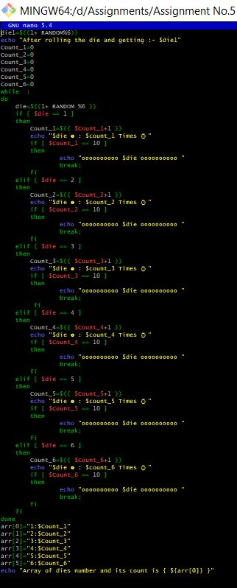

**Output: -**

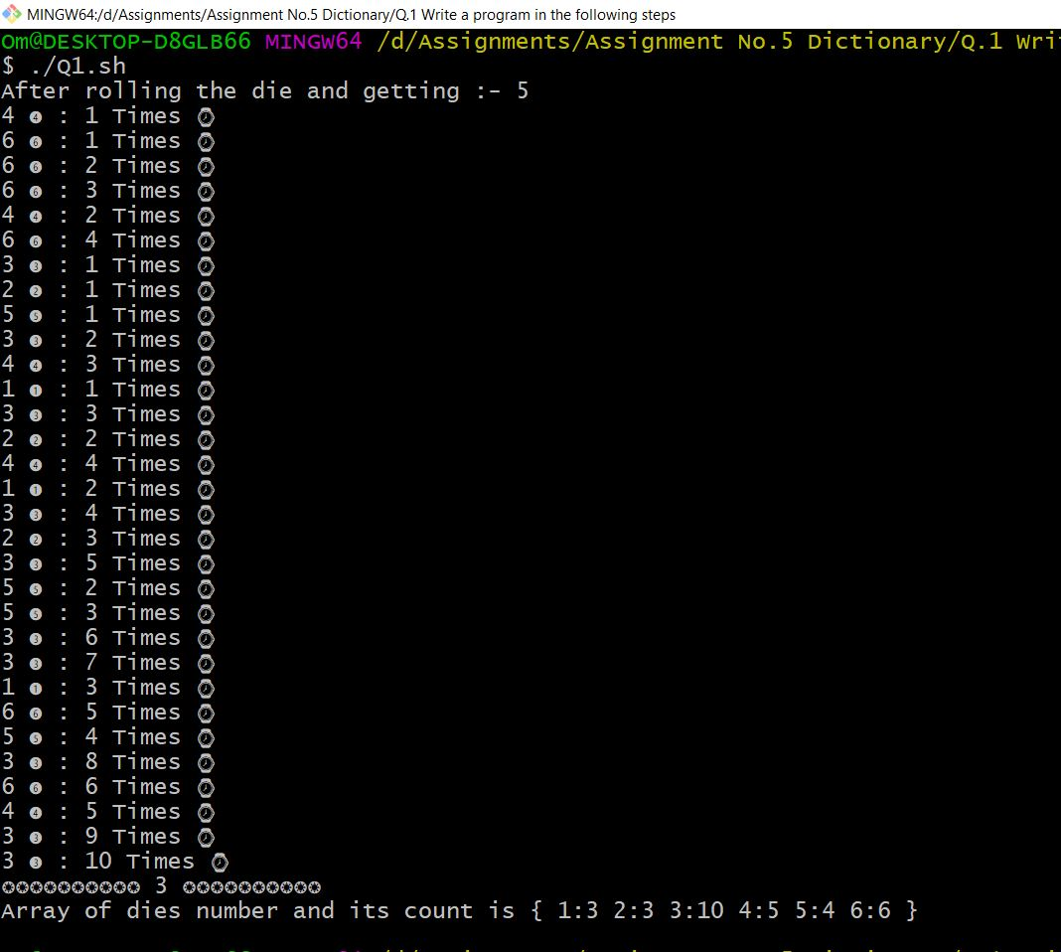

**Q.2 Write a Program to generate a birth month of 50 individuals between the year 92 & 93. Find all the individuals having birthdays in the same month. Store it to finally print.**

**Code: -**

for(( i=0; i<=50;i++ ))

do

Month=$(( 1 + $RANDOM%12 ))

Year=$(( 1992 + $RANDOM%2 ))

if [ $Month == 1 ] | [ $Month == 3 ] | [ $Month == 5 ] | [ $Month == 7 ] | [ $Month == 8 ] | [ $Month == 10 ] | [ $Month == 12 ]

then

Date=$(( 1 + $RANDOM % 31 ))

elif [ $Month == 2 ]

then

if [ $Year == 1992 ]

then

Date=$(( 1+ $RANDOM % 29 ))

else

Date=$(( 1 + $RANDOM % 28))

fi

arr02[$i]=$Date/$Month/$Year

else

Date=$(( 1 + $RANDOM % 30 ))

if [ $Month == 4 ]

then

arr04[$i]=$Date/$Month/$Year

elif [ $Month == 6 ]

then

arr06[$i]=$Date/$Month/$Year

elif [ $Month == 9 ]

then

arr09[$i]=$Date/$Month/$Year

elif [ $Month == 11 ]

then

arr11[$i]=$Date/$Month/$Year

fi

fi

if [ $Month == 1 ]

then

arr01[$i]=$Date/$Month/$Year

elif [ $Month == 3 ]

then

arr03[$i]=$Date/$Month/$Year

elif [ $Month == 5 ]

then

arr05[$i]=$Date/$Month/$Year

elif [ $Month == 7 ]

then

arr07[$i]=$Date/$Month/$Year

elif [ $Month == 8 ]

then

arr08[$i]=$Date/$Month/$Year

elif [ $Month == 10 ]

then

arr10[$i]=$Date/$Month/$Year

elif [ $Month == 12 ]

then

arr12[$i]=$Date/$Month/$Year

fi

echo "$Date/$Month/$Year"

arr[$i]=$Date/$Month/$Year

done

echo ""

echo " ㏈㏈㏈㏈㏈㏈㏈㏈㏈㏈㏈㏈㏈㏈㏈㏈ Date Of Birth 50 Person ㏈㏈㏈㏈㏈㏈㏈㏈㏈㏈㏈㏈㏈㏈㏈㏈"

#echo "\n ${arr[*]}"

echo ""

echo "❆❆❆❆❆❆❆❆❆❆❆❆❆❆❆❆ Birth Month : ❶ January ❆❆❆❆❆❆❆❆❆❆❆❆❆❆❆❆"

echo ${arr01[*]}

echo ""

echo "❆❆❆❆❆❆❆❆❆❆❆❆❆❆❆❆ Birth Month : ❷ February ❆❆❆❆❆❆❆❆❆❆❆❆❆❆❆❆"

echo ${arr02[*]}

echo ""

echo "☀☀☀☀☀☀☀☀☀☀☀☀☀☀☀☀ Birth Month : ❸ March ☀☀☀☀☀☀☀☀☀☀☀☀☀☀☀☀ "

echo ${arr03[*]}

echo ""

echo "☀☀☀☀☀☀☀☀☀☀☀☀☀☀☀☀ Birth Month : ❹ April ☀☀☀☀☀☀☀☀☀☀☀☀☀☀☀☀ "

echo ${arr04[*]}

echo ""

echo "☀☀☀☀☀☀☀☀☀☀☀☀☀☀☀☀ Birth Month : ❺ May ☀☀☀☀☀☀☀☀☀☀☀☀☀☀☀☀ "

echo ${arr05[*]}

echo ""

echo "☀☀☀☀☀☀☀☀☀☀☀☀☀☀☀☀ Birth Month : ❻ June ☀☀☀☀☀☀☀☀☀☀☀☀☀☀☀☀ "

echo ${arr06[*]}

echo ""

echo "☂☂☂☂☂☂☂☂☂☂☂☂☂☂☂☂ Birth Month : ❼ July ☂☂☂☂☂☂☂☂☂☂☂☂☂☂☂☂"

echo ${arr07[*]}

echo ""

echo "☂☂☂☂☂☂☂☂☂☂☂☂☂☂☂☂ Birth Month : ❽ August ☂☂☂☂☂☂☂☂☂☂☂☂☂☂☂☂ "

echo ${arr08[*]}

echo ""

echo "☂☂☂☂☂☂☂☂☂☂☂☂☂☂☂☂ Birth Month : ❾ September ☂☂☂☂☂☂☂☂☂☂☂☂☂☂☂☂"

echo ${arr09[*]}

echo ""

echo "☂☂☂☂☂☂☂☂☂☂☂☂☂☂☂☂ Birth Month : ❿ October ☂☂☂☂☂☂☂☂☂☂☂☂☂☂☂☂ "

echo ${arr10[*]}

echo ""

echo "❆❆❆❆❆❆❆❆❆❆❆❆❆❆❆❆ Birth Month : ❶❶ November ❆❆❆❆❆❆❆❆❆❆❆❆❆❆❆❆"

echo ${arr11[*]}

echo ""

echo "❆❆❆❆❆❆❆❆❆❆❆❆❆❆❆❆ Birth Month : ❶❷ December ❆❆❆❆❆❆❆❆❆❆❆❆❆❆❆❆ "

echo ${arr12[*]}

echo ""

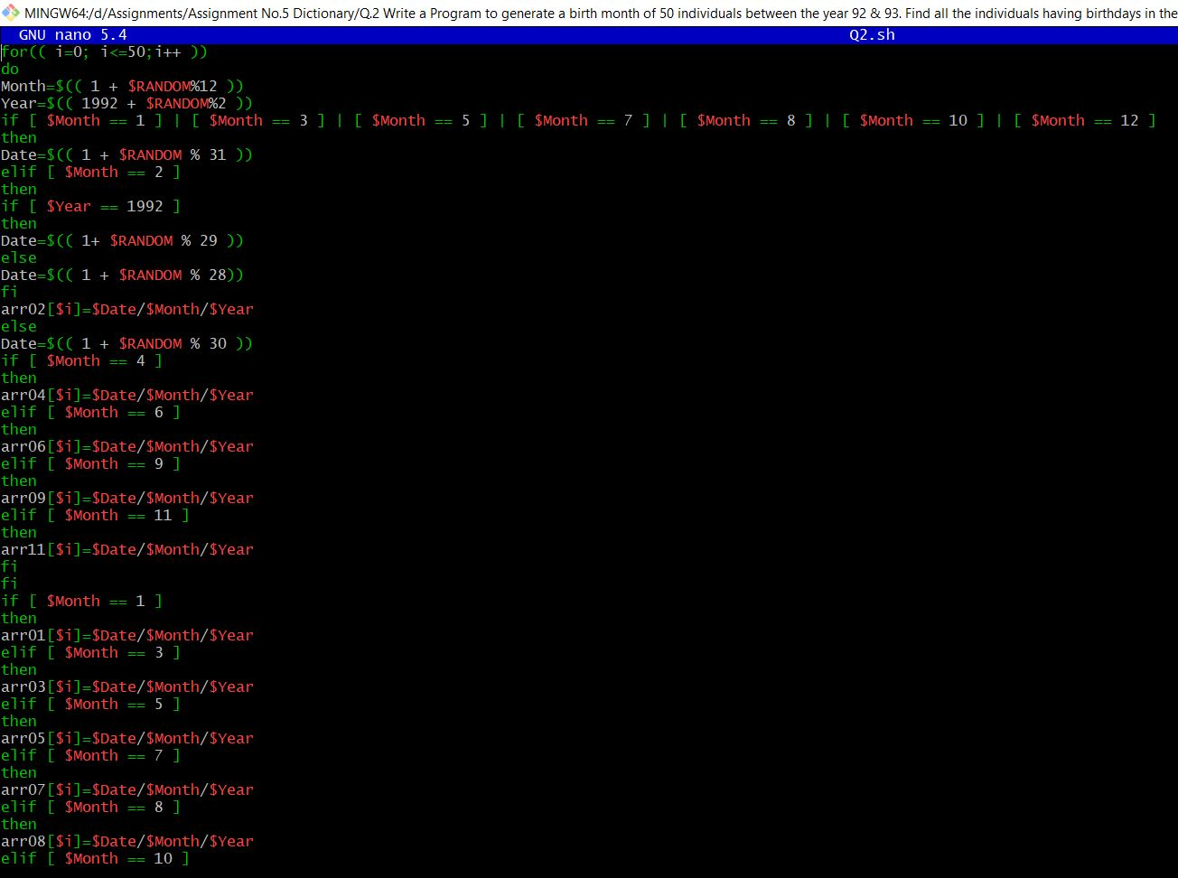

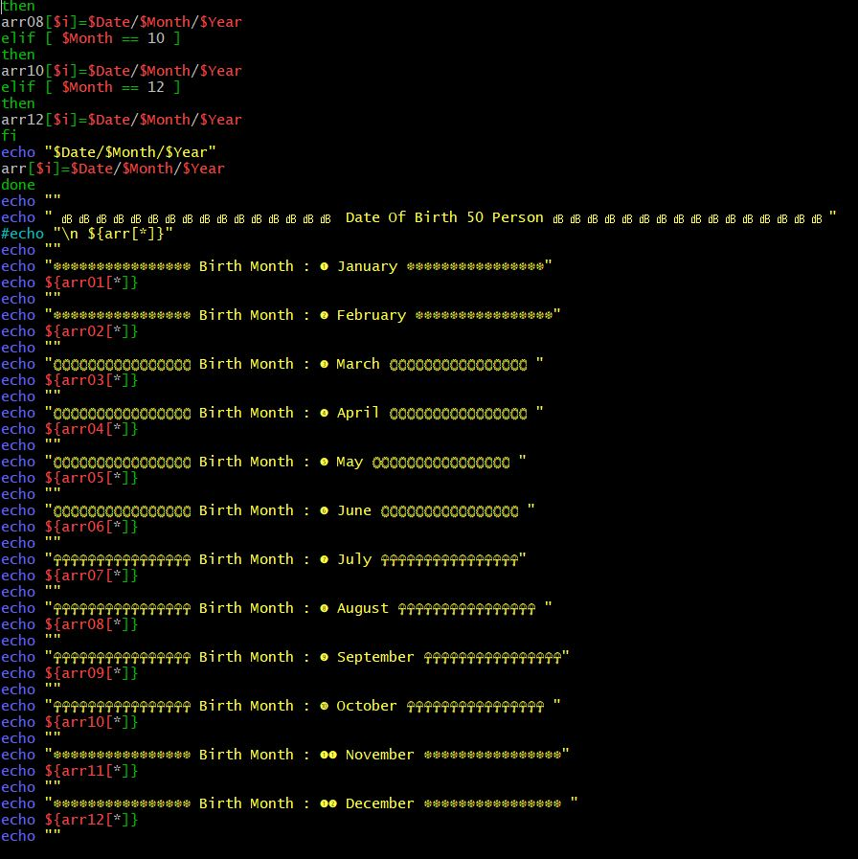

**Output: -**

